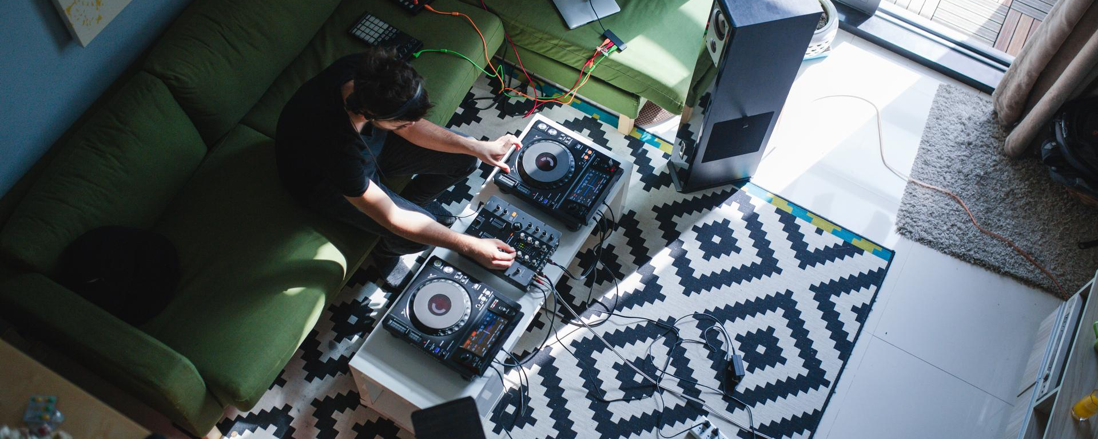 Celebrate Make Music Day…
…and enjoy the upcoming #Don’tStopTheMusic live streams

Wedemark/Germany, June 16, 2020 – June 21 is a special day for all lovers of music – around the world people are celebrating Make Music Day or Fête de la Musique! Originating in France, this unique annual celebration now takes place in more than 1000 cities and in 120 countries around the world and seeks to encourage participation in music at every level. Normally, the day is all about coming together to enjoy free live events in venues and public spaces, but in the year of the coronavirus, things are of course different… And yet the music plays on: Many events are moving online, and Sennheiser is excited to dedicate its own #DontStopTheMusic concerts this week and next to this inspirational project.

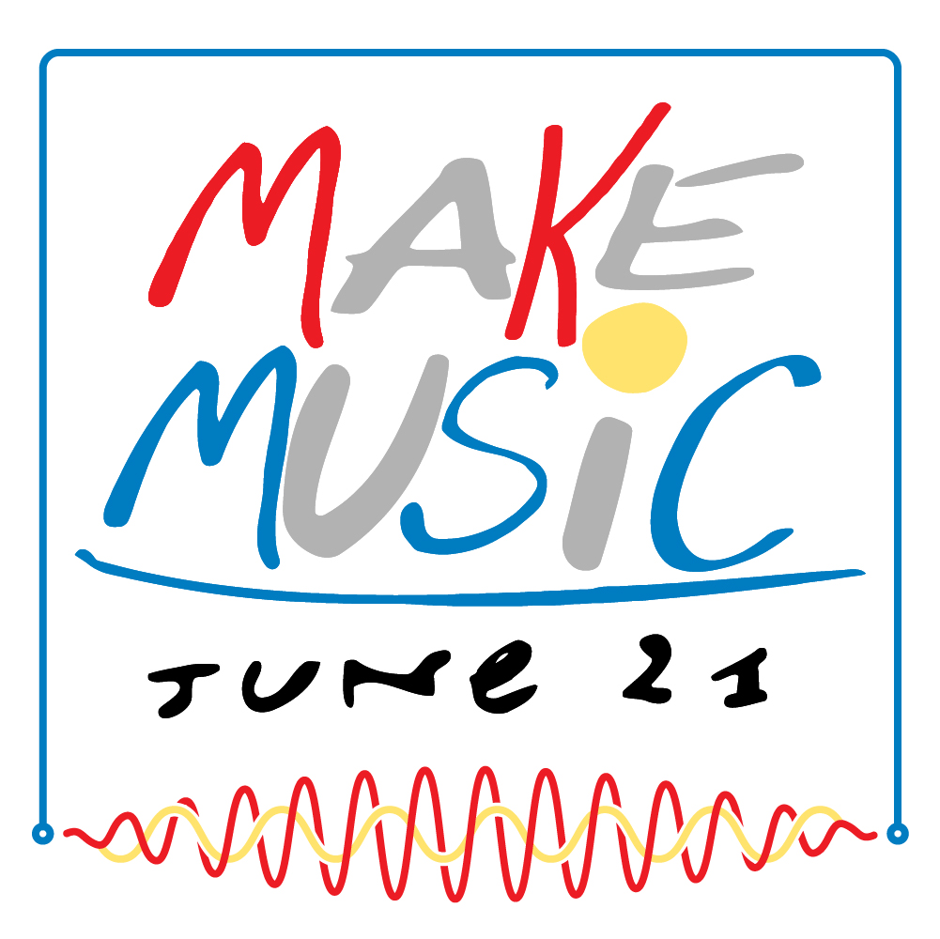 | Make Music Day is celebrated in 120 countries around the world  Logo courtesy of makemusicday.org

This month, audio specialist Sennheiser is also celebrating a unique musical story – marking 75 years since the company’s foundation in 1945. Today, and through its history, Sennheiser has been proud to support artists in the creation and sharing of music.

“Whether you're a singer songwriter recording your first track, a superstar who’s filling stadiums or a DJ mixing up a storm, audio equipment has always been about making it easier to express oneself through music,” said Pierre Morant, Head of Relationship Management, Sennheiser. “However, more important than the instruments or the equipment is the passion for making, listening and sharing music that is at the start of every musical journey which ‘Make Music Day’ celebrates. During these two weeks we are really excited to play a part in keeping the music alive with performances from some great talent as part of our #DontStopTheMusic initiative.”

As part of its 75th anniversary – and throughout the coronavirus shutdown – Sennheiser’s #DontStopTheMusic has been keeping live music going strong. The exclusive, free, live-streamed concerts have seen artists from around the globe performing to audiences at home. This week and next, Sennheiser will present concerts by Hudson Thames on June 17, Aedan on June 19, Nic Hanson on June 22, Callaghan on June 24 and Solardo on June 26. Sennheiser’s #DontStopTheMusic series are streamed on Facebook.

Get involved with Make Music Day!
Make Music Day is all about getting involved – whether you are spectating and listening online or making music with your family or a friend. Some cities are also organizing small events that respect smart distancing and other coronavirus restrictions. If your city has a Make Music or a Fête de la Musique organization, check out their website and see how you can celebrate your very own Make Music Day.

About Sennheiser
Founded in 1945, Sennheiser is celebrating its 75th anniversary this year. Shaping the future of audio and creating unique sound experiences for customers – this aim unites Sennheiser employees and partners worldwide. The independent family company, which is managed in the third generation by Dr. Andreas Sennheiser and Daniel Sennheiser, is today one of the world’s leading manufacturers of headphones, loudspeakers, microphones and wireless transmission systems. In 2018, the Sennheiser Group generated turnover totalling €710.7 million. www.sennheiser.com

Global press contact

Stephanie Schmidt
stephanie.schmidt@sennheiser.com
+49 (5130) 600 – 1275

